Question 1:
Write a java program to add the two numbers.

Week 3
import java.util.Scanner;
public class One {
public static void main(String[] args) {
try (Scanner scan = new Scanner(System.in)) {
System.out.print("Enter first number: ");
double num1 = scan.nextDouble();
System.out.print("Enter second number: ");
double num2 = scan.nextDouble();
double result = num1 + num2;
System.out.printf("Addition result of %.2f and %.2f is: %.2f", num1, num2, result);
}
}
}

Code:

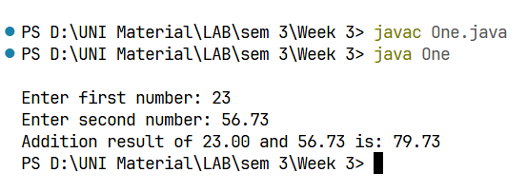
Output:

Code:
Question 2: 1
Write a java program to multiply two floating numbers.

import java.util.Scanner;
public class Two {
public static void main(String[] args) {
try (Scanner scan = new Scanner(System.in)) {
System.out.print("Enter first number: ");
double num1 = scan.nextDouble();
System.out.print("Enter second number: ");
double num2 = scan.nextDouble();
double result = num1 * num2;
System.out.printf("Multiplication result of %.2f and %.2f is: %.2f", num1, num2, result);
}
}
}

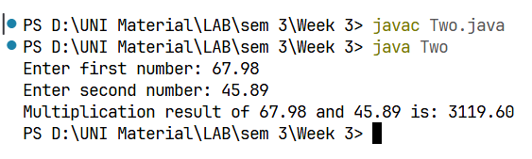
Output:

import java.util.Scanner;
public class Three {
public static void main (String[] args){
try (Scanner scan = new Scanner(System.in)) {
System.out.print("Enter the number: ");
double num = scan.nextDouble();
double result = num*num*num;
System.out.printf("Cube of %.2f is: %.2f",num, result);
}
}
}

Code:
Question 3:
Write a java program to display a cube of a number.

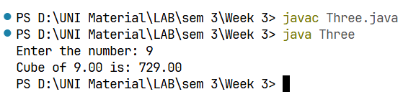
Output:

Question 4:
Write a Java program that takes three numbers as input to calculate and print the average of the numbers.

import java.util.Scanner;
public class Three {
public static void main (String[] args){
try (Scanner scan = new Scanner(System.in)) {
System.out.print("Enter the number: ");
double num = scan.nextDouble();
double result = num*num*num;
System.out.printf("Cube of %.2f is: %.2f",num, result);
}
}
}

Code:

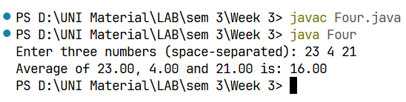
Output:
import java.util.Scanner;
public class Five {
public static void main(String[] args) {
try (Scanner scan = new Scanner(System.in)) {
System.out.print("Enter the first point (space separated - x y): ");
double x1 = scan.nextDouble();
double y1 = scan.nextDouble();
System.out.print("Enter the second point (space separated - x y): ");
double x2 = scan.nextDouble();
double y2 = scan.nextDouble();
double distance = Math.sqrt( ( (x1 - x2)*(x1 - x2) ) + ( (y1 - y2)*(y1-y2) ) );
System.out.printf("Distance between (%.2f, %.2f) and (%.2f, %.2f) is: %.2f", x1, y1, x2, y2, distance);
}
}
}

Code:
Question 5:
Write a Java program to compute the distance between two points.

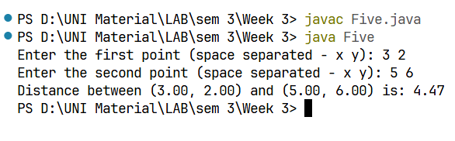
Code:
import java.util.Scanner;
public class Six {
public static void main(String[] args) {
try (Scanner scan = new Scanner(System.in)) {
System.out.print("Enter first number (a): ");
int a = scan.nextInt();
System.out.print("Enter second number (b): ");
int b = scan.nextInt();
System.out.printf("Before swapping: a = %d, b = %d\n", a, b);
int temp = a;
a = b;
b = temp;
System.out.printf("After swapping: a = %d, b = %d\n", a, b);
}
}
}

Question 6:
Write a Java program to compute the distance between two points.

Optional
Output:
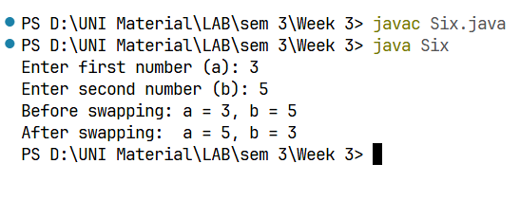
Output:
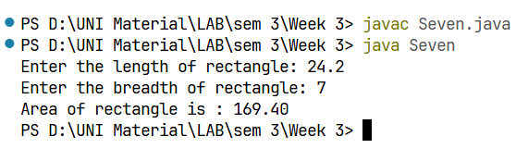
import java.util.Scanner;
public class Seven {
public static void main(String[] args) {
try (Scanner scan = new Scanner(System.in)) {
System.out.print("Enter the length of rectangle: ");
double length = scan.nextDouble();
System.out.print("Enter the breadth of rectangle: ");
double breadth = scan.nextDouble();
double area = length*breadth;
System.out.printf("Area of rectangle is : %.2f", area);
}
}
}

Code:
Question 7:
Write a Java program to calculate the area of a rectangle given its lengthand breadth.

import java.util.Scanner;
public class Eight {
public static void main(String[] args) {
try (Scanner scan = new Scanner(System.in)) {
System.out.println("Select the unit you want to convert FROM:");
System.out.println(" 1. Celsius (C or c)");
System.out.println(" 2. Fahrenheit (F or f)");
System.out.print("Enter your choice (1/C or 2/F): ");
String input = scan.next().toLowerCase();
switch (input) {
case "1", "c" -> {
System.out.print("Enter temperature in Celsius: ");
double celsius = scan.nextDouble();
double fahrenheit = (celsius * 9.0 / 5) + 32;
System.out.printf("%.2f°C = %.2f°F\n", celsius, fahrenheit);
}
Code:
Write a Java program to convert temperature from Celsius to Fahrenheit

Question 8:
case "2", "f" -> {
System.out.print("Enter temperature in Fahrenheit: ");
double fahrenheit = scan.nextDouble();
double celsius = (fahrenheit - 32) * 5.0 / 9;
System.out.printf("%.2f°F = %.2f°C\n", fahrenheit, celsius);
}
default -> System.out.println(" Invalid input. Please enter 1, 2, C, or F.");
}
}
}
}

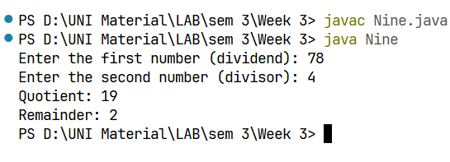
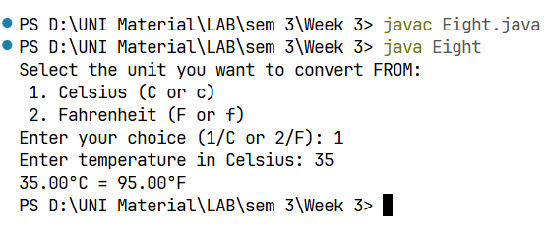
Output:
Output:
import java.util.Scanner;
public class Nine {
public static void main(String[] args) {
try (Scanner scan = new Scanner(System.in)) {
System.out.print("Enter the first number (dividend): ");
int num1 = scan.nextInt();
System.out.print("Enter the second number (divisor): ");
int num2 = scan.nextInt();
int quotient = num1 / num2;
int remainder = num1 % num2;
System.out.println("Quotient: " + quotient);
System.out.println("Remainder: " + remainder);
}
}
}

Write a Java program that takes two integer inputs and computes their remainder and quotient.

Code:
Question 9:
Output:
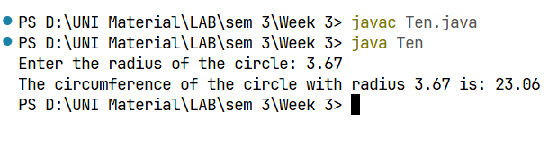
Question 10:
Output:
import java.util.Scanner;
public class Ten {
public static void main(String[] args) {
try(Scanner scan = new Scanner(System.in)){

System.out.print("Enter the radius of the circle: ");
double radius = scan.nextDouble();

double circumference = 2 * Math.PI * radius;
System.out.printf("The circumference of the circle with radius %.2f is: %.2f\n", radius, circumference);
}
}
}

Write a Java program to find the circumference of a circle given its radius.

Code:

